An Investigation into the Factors Affecting the Velocity of a Gauss Gun Projectile

Joseph Dillman

Physics

Sir Winston Churchill Secondary School

May 2016

Word Count: 3942

**Abstract**

In this essay I have attempted to answer the question regarding how certain factors such as friction and the addition of steel balls and magnets affects the velocity of a Gauss gun projectile. Five neodymium rare earth magnets and up to thirty-six steel balls were spaced apart on a custom built track and elastically collided together in order to conserve and transfer electromagnetic potential energy into kinetic energy. The velocity of the final projectile was successfully calculated using slow motion video analysis with the mass of the projectiles and track length being known. A newton-meter was also used in order to calculate forces of friction between the projectiles and the track. After constructing the track, the first portion of the experiment consisted of recording the velocity of the final steel ball versus the total number of steel balls grouped behind the neodymium magnet on the track, known as end balls. It was found that using five end balls behind each neodymium magnet yielded the highest velocity of 2.86m/s ± 3%. Once this was found, the second part of the experiment was conducted in finding the relationship between the number of total magnets used and final kinetic energy of the projectile. The equation for kinetic energy versus number of magnets was found to be KE = (0.00970J/n ± 0.000740)n + 0.00330J ± 6%. Finally, the coefficient of friction between the steel ball and the wooden track was calculated to be µ = 0.21 ± 10% with a negative acceleration from the force of friction being 2.1m/s2 ± 10%. Although values yielded were nowhere close to those found in conventional weapons such as hand guns, the Gauss gun is nevertheless a brilliant display of fundamental laws of physics such as the conservation of energy and Newton’s first law of inertia.

Word count: 298.

**Table of Contents**

Introduction 1

Hypothesis 2

Variables 3

Materials 4

Design 4

Procedure 5

Constructing the track 5

Finding the coefficient of friction between steel balls and the track 5

Finding the optimum number of end balls 6

Finding the relationship between the velocity and number of stations 7

Observations 7

Analysis 8

Calculating the speed of the projectiles 8

Calculating the kinetic energy of projectiles 10

Calculating the coefficient of friction 12

Evaluation and Conclusion 13

References 15

Appendices 16

# **Introduction**

A Gauss gun, also referred to as a Gaussian gun or Gauss rifle, is a projectile accelerator conceived by the German mathematician Johann Carl Friedrich Gauss (Levi et al., 1991). The gauss gun constructed in this experiment consists of strong spherical neodymium rare earth metal magnets spaced apart on top of a track with several steel balls following behind each magnet. These steel balls preceding the magnet do not have a specific name but I will be referring to them in this essay as “end balls”. Each cluster consisting of one magnet with several end balls behind in a line will be referred to as “stations” (see figure 1).

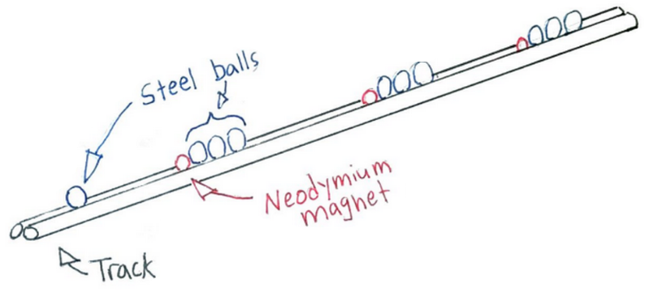



*Figure 1. A sketch of the Gauss gun designed in this experiment*

A steel ball is placed in front the first magnet and is slowly moved forward until it enters its magnetic field and collides. In an elastic collision the kinetic energy is transferred through the station due to the conservation of momentum and energy, similar to the collision found in a Newton’s cradle (Hecht, 1998). The final end ball will receive the kinetic energy which was formerly stored as magnetic potential energy in the magnet. The final end ball can continue to contact another station to repeat the process transferring its momentum to the next steel ball increasing its velocity. More stations will result in a faster end ball (see figure 2).

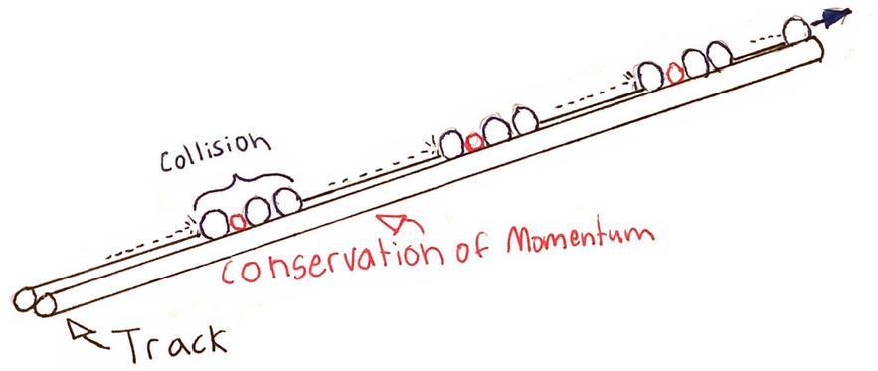

*Figure 2. A sketch of a Gauss gun once fired*

As magnetism and electrical energy become more accessible there is a possibility that Gauss guns may be more applicable as weapons. Today railguns are used in the United States Navy which harnesses magnetic forces to accelerate projectiles. One experimental US navy railgun was capable of shooting a 3.2 kg projectile at speeds of 8600 km/h (Borrell, 2008). Perhaps a Gauss gun could one day be used as a form of weaponry.

There are many factors to consider when determining the velocity of the final end ball of a Gauss gun. Forces of friction are constantly acting upon the steel balls and magnets at all times. The kinetic energy of projectiles is hindered as they slide along the surface of the track. Following the magnet are end balls which separate the projectile from the magnet. Having too few end balls following the magnet will reduce the final velocity of the projectile as the attraction between the magnet and the projectile may be too great before the collision occurs. On the contrary, having too many end balls following the magnet may reduce the efficiency in the conservation of momentum as forces are lost to heat, friction, and sound (Giancoli, 1991). Changing the number of end balls and stations and taking into account other factors such as friction against the track can have large implications on the final velocity of the Gauss gun projectile. Answering and investigating this question will be explored in this essay.

# **Hypothesis**

Each station of the Gauss gun is represented by a neodymium magnet with end balls placed behind. The distance between each station is set by the minimum distance before the magnetic force attracts the steel ball of the station in front of it. The force of friction against the surface is constant in this experiment and is a controlled variable. What will be manipulated in this experiment is the number of end balls following the neodymium magnet and the number of stations. Figures 1 and 2 show three end balls to the right of the neodymium magnet, however more or less will likely have an effect on the final velocity which is what I will observe. Having too few end balls will cause the final end ball to attract to the magnet with too much force and the final velocity will be hindered. Having too many end balls following the magnet will result in more energy being lost to friction, heat, and sound where momentum is not perfectly transferred. If it is true that the number of end balls following the neodymium magnet directly affects the transfer of energy to the final end ball, then adding about 3 to 5 end balls should yield the highest velocity as it is not so little that magnetic attractions hinder results or too much that energy is lost to heat or friction. Once it is determined what the best number of end balls is, the second portion of the experiment can begin which will consist of finding the relationship between adding more stations and the kinetic energy of the projectile. This relationship should be linear.

# **Variables**

The independent variable for the first part of the experiment will be the number of end balls following the neodymium magnet. This number will range from 1 to 10. The dependent variable will be the velocity of the projectile. In the second part of the experiment the independent variable will be the number of stations which range from 1 to 5. The dependent variable will be the kinetic energy of the projectile. The testing area for this experiment will be inside a closed, openly spaced room with little to no wind. All tests will be taken inside the same room with the same materials. The following will all be closely controlled during the experiment:

* Coefficient of friction between the projectile and track
* Size and shape of the track
* Size, shape and weight of steel balls
* Size, shape and weight of magnets
* Wind
* Temperature
* Distance between magnets when spaced apart on the track

# **Materials**

* Track
  + Two wooden poles, 1.11 x 121.92 cm (7/16 x 48”)
  + One thin wooden pole, 0.64 x 121.92 cm (1/4 x 48”)
  + Hot glue gun
  + Clippers
  + Tape
  + Marker
* Tape Measure, minimum 1 meter
* 5 spherical neodymium magnets, 1.27 cm (1/2”)
* 36 spherical steel balls, 1.39 cm (6/11”)
* 2.5N newton-meter
* Weight scale
* Casio EXILIM EX-ZR750 16.1 MP digital camera for slow motion video capture
* Computer capable of running Pasco Capstone video analysis software
* Eye protection
* Net/catcher to be placed at the end of the track

# **Design**

The Gauss gun shoots small projectiles at relatively high speeds for this physics experiment. The velocity of the end ball is essentially the bullet of the Gauss gun and in order to analyze the Gauss gun itself the velocity must be obtained in some way. The best method will be to use slow motion video along with video analysis technology to calculate the velocity. The camera for this experiment will be the Casio EXILIM EX-ZR750 which is capable of shooting up to 1000 frames per second. The video analysis software will be Pasco Capstone which is able to determine the velocity of the projectile. However, this can only be done with a reference length in the video such as a tape measure which can be measured with very high accuracy and precision. The video in this experiment will be shot at 480 frames per second, also resulting in high accuracy and precision. The mass of the projectile can be weighed as well with sufficiently lower errors. With this design, high velocities will be analyzable as long as all portions of the apparatus are present such as the tape measure marker.

# **Procedure**

## **Constructing the track**

1. Two 1.11cm wooden poles were set together lengthwise so that they were touching along the entire way down.
2. The two poles were then taped together. I ensured that the track was straight during storage to prevent the poles from bending or deforming. The tape was temporary and would be removed later.
3. 9 pieces about 4 cm long each were cut from the thinner 0.635 cm pole.
4. The two longer wooden poles were held together by applying hot glue to the smaller 4cm pieces and placing them underneath to construct a train track-like rail (see figure 3). Gloves are recommended for handling hot glue.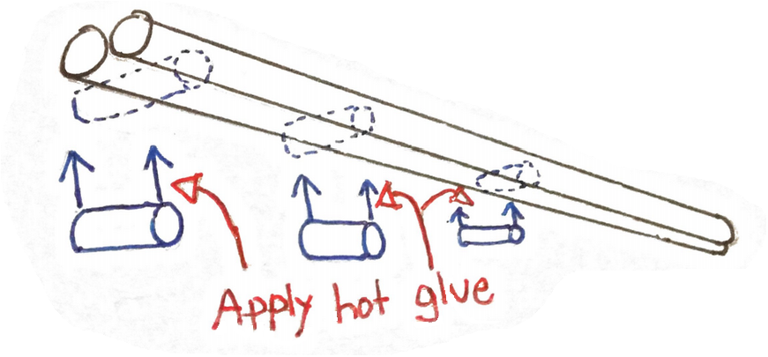

*Figure 3. Shorter pieces were glued to the bottom of the two poles to keep the track secure*

1. Once the glue has been applied and hardened, I removed the tape from step 2. I also examined the track to ensure it was straight and level with the floor.
2. 0.500 meters was measured out with the tape measure and marked down on the track to give the camera a reference point during video analysis.
3. A ball catcher was placed at the end of the track and made by reinforcing a ziplock bag with pieces of the 0.635 cm pole. Any normal bag or cloth would also work.

## **Finding the coefficient of friction between steel balls and the track**

1. One of the steel balls was weighed using an electronic weight scale.
2. The newton-meter was zeroed.
3. Twenty steel balls were placed onto the track and connected together with a piece of tape. Then I hooked the newton-meter to the end of the chain. The reason I did this was because one steel ball was simply too light to register anything on a standard 2.5N newton-meter. With twenty steel balls in total, the force of friction can be registered with enough significant figures and reasonably low errors.
4. The newton-meter was slowly pulled at a constant speed and the amount of force shown on the meter was recorded.

## **Finding the optimum number of end balls**

1. Eye protection was necessary during this portion of the experiment as collisions and projectiles are involved. All other persons in the room should also be notified to prevent injury. The room itself should be specious enough to safely conduct the experiment.
2. The track was set with the catching net at the end. I also ensured that the view of the video camera was able to capture the tape on the track displaying the points of the 0.500 meter distance (See appendix 1 for photos of the apparatus).
3. 5 neodymium magnets were placed along the track with 2 end balls behind it. Each station was separated 3 cm apart, slightly larger than the magnet’s magnetic field.
4. The slow motion camera was turned to 480 frames per second. The meter stick was also made sure to be in the view of the camera displaying the length of 0.500m.
5. A steel ball was very slowly pushed onto the track and moved until it attracted to the first station. If the ball is pushed towards the first station too quickly then extraneous forces from my hand will affect the final velocity.
6. After the steel ball came into contact with the first station, the acceleration took place and the final velocity was recorded on the camera and saved.
7. Steps 3 to 5 were repeated three more times to obtain an average.
8. Steps 3 to 7 were repeated five more times using 3, 4, 5, 6, and 7 end balls.
9. All videos were analyzed in Pasco Capstone to find the velocities of the projectiles (see appendix 2 for details on video analysis).
10. The optimum number of end balls should be known which allows me to move to part two of the experiment.

## **Finding the relationship between the velocity and number of stations**

1. Once again, the track, net, and camera were set up in the same configuration as before.
2. I started with just one neodymium magnet followed by the optimum number of end balls, which in this experiment was calculated it to be five end balls.
3. With the camera set to 480 frames per second, a steel ball was placed on the track and slowly pushed until it entered the magnetic field.
4. The necessary video was recorded in order to find the velocity.
5. Steps 2 to 4 were repeated three more times to obtain an average.
6. I repeated steps 2 to 6 were repeated four more times using 2, 3, 4, and 5 stations, all with the optimum number of end balls which was 5.
7. All videos were analyzed in Pasco Capstone to find the velocities of the projectiles.

# **Observations**

There are a total of two separate observations in this experiment regarding time. The first is finding the optimum number of end balls while the second is finding the relationship between the number of stations and the kinetic energy. The value of time in the video analysis is 16 times slower than the real time as the video was shot at 480 fps and then viewed at 30 fps. The amount of time for the projectiles to pass half a metre in the two sets of observations is displayed below.

|  |  |
| --- | --- |
| Number of end balls | Average time for projectile to pass half a meter (seconds, slowed time) ± 0.05 seconds |
| 2 | 3.16 |
| 3 | 2.89 |
| 4 | 2.82 |
| 5 | 2.80 |
| 6 | 2.93 |
| 7 | 3.03 |

|  |  |
| --- | --- |
| Number of Stations | Average time for projectile to pass half a meter (seconds, slowed time) ± 0.05 seconds |
| 1 | 6.33 |
| 2 | 4.00 |
| 3 | 3.28 |
| 4 | 3.03 |
| 5 | 2.80 |

In calculating the coefficient of friction, the mass of twenty steel balls and the force of friction are recorded.

Mass of one steel ball: 12.08 ± 0.01g

Force of friction between twenty steel balls and track: 0.50 ± 0.05N

(See appendix 3 for a full list of raw data)

# **Analysis**

## **Calculating the speed of the projectiles**

The first calculation that must be done in order to find the velocity of the projectiles is to convert the slowed video analysis time into real time. The video analysis was conducted in 480 frames per second while being viewed at 30 frames per second. . Therefore, the recorded time values must be divided by 16 in order to obtain the real time values. Because the distance is known to be 0.500m ± 0.005, a simple kinematics equation can be used to find the velocity. Below is an example calculation for the first value (2 end balls).

Below are the calculated velocities for the two observations. The uncertainty calculations for time were all calculated to be 2% to one significant figure due to the close range of values. The uncertainty calculation for the distance was 1%. This gave a velocity uncertainty of 3%.

|  |  |  |  |
| --- | --- | --- | --- |
| Number of end balls | Video analysis time (seconds) ± 0.05 | Real time (seconds) ± 2% | Velocity (m/s) ± 3% |
| 2 | 3.16 | 0.198 | 2.53 |
| 3 | 2.89 | 0.181 | 2.77 |
| 4 | 2.82 | 0.176 | 2.84 |
| 5 | 2.80 | 0.175 | 2.86 |
| 6 | 2.93 | 0.183 | 2.73 |
| 7 | 3.03 | 0.189 | 2.64 |

In this instance, some uncertainties were calculated to be only 2%.

|  |  |  |  |
| --- | --- | --- | --- |
| Number of Stations | Video analysis time (seconds) ± 0.05 | Real Time (seconds) | Velocity (m/s) |
| 1 | 6.33 | 0.396 ± 1% | 1.26 ± 2% |
| 2 | 4.00 | 0.250 ± 1% | 2.00 ± 2% |
| 3 | 3.28 | 0.205 ± 2% | 2.44 ± 3% |
| 4 | 3.03 | 0.189 ± 2% | 2.64 ± 3% |
| 5 | 2.80 | 0.175 ± 2% | 2.85 ± 3% |

The results showed that having a total of 5 end balls yielded the fastest velocity for the Gauss gun with a value of 2.86 m/s ± 3%. The slowest velocity was deduced from the 2 end ball group with a speed of 2.53 m/s ± 3%. The largest difference in velocity occurred between 2 and 3 end balls. After the third end ball the velocities would slowly rise to the peak of 5 end balls and would then start decreasing.

The shape of the data set is likely due to the electromagnetic field of the neodymium ball and friction. Having only two end balls means that the final end ball is closer to the magnet, thus the force of the magnet is stronger on the steel ball than if the ball were spaced farther away. Having more end balls (for example five instead of two) means the final end ball is further away from the neodymium magnet’s field, making it easier for the end ball to leave the station. That being said, if there are too many end balls (for example seven instead of five) the extra distance from the magnet is negligible and does not positively affect the velocity. Having too many end balls results in a slower velocity because there is a greater chance of energy being lost to heat, sound, and friction as there are more areas of contact and more mass that the kinetic energy must pass through. This is why a middle ground of 5 end balls is optimum.

## **Calculating the kinetic energy of projectiles**

The gauss gun constructed in this experiment greatly resembles a Newton’s cradle as both are based upon three main principles. The first principle is Newton’s first law in that the net force is the vector sum of all forces.

The second principle is the law of conservation of energy. Kinetic energy and electromagnetic potential energy (the total energy) will be conserved when ignoring friction.

Finally the law of conservation of momentum states that the forces between two objects in a collision are equal and opposite. Because the collision in the Gauss gun is elastic, very little to no kinetic energy is lost. With this information in mind, the electromagnetic potential energy of the magnets can be determined if energy lost due to other sources such as friction is ignored. Before the collision all magnets and steel balls are at rest and so the kinetic energy of the system is at zero. After the collisions the electromagnetic potential energy is converted into kinetic energy which is transferred to the final projectile due to the law of conservation of momentum and energy. The final projectile is the sum of the electromagnetic potential energies stored in the magnets that preceded it. After the collision the projectile is not significantly charged so the electromagnetic potential energy of the projectile is zero. I now get this equation:

Taking this into account, I can calculate the energy of the projectile as well as the potential energy that was stored in the magnets before the collision occurred. The mass of one steel ball is 12.08g ± 0.01. Below is an example calculation for the first value of kinetic energy (2 end balls).

Below are the rest of the calculations for the kinetic energy of the final projectile for both sets of data. The mass of the steel balls remained constant.

|  |  |  |
| --- | --- | --- |
| Number of end balls | Velocity (m/s) ± 3% | Kinetic Energy (J) ± 6% |
| 2 | 2.53 | 0.0387 |
| 3 | 2.77 | 0.0463 |
| 4 | 2.84 | 0.0487 |
| 5 | 2.86 | 0.0494 |
| 6 | 2.73 | 0.0450 |
| 7 | 2.64 | 0.0421 |

|  |  |  |
| --- | --- | --- |
| Number of Stations | Velocity (m/s) | Kinetic Energy (J) |
| 1 | 1.26 ± 2% | 0.00959 ± 4% |
| 2 | 2.00 ± 2% | 0.0242 ± 4% |
| 3 | 2.44 ± 3% | 0.0369 ± 6% |
| 4 | 2.64 ± 3% | 0.0421 ± 6% |
| 5 | 2.85 ± 3% | 0.0491 ± 6% |

­­

Original slope:

Slope max

Slope min

Slope uncertainty

Final equation:

The graph shows a linear trend. The energy values can be accepted as either kinetic energy or the electromagnetic potential energy of the magnets if other factors such as friction are ignored. According to the equation derived from the graph, a Gauss gun with 100 stations would produce a projectile with a kinetic energy of only 0.973 joules. This value is completely dwarfed by the kinetic energy of an average 9mm pistol which is given as 519, however, considering that this Gauss gun only uses magnets, this figure is not entirely insignificant. Although, there is a possibility that if the graph were to be extrapolated to 100 stations, the equation could look logarithmic as air resistance comes into play and the projectiles reach a terminal velocity. The results of this graph show that the addition of stations has a very gradual and small effect on the final projectile. If the highest velocity is desired, perhaps using a stronger magnet would yield better results than using several weaker magnets.

## **Calculating the coefficient of friction**

There are several factors that inhibit the kinetic energy of the final ball, one significant factor would be the force of friction between the steel ball and the track. At lower velocities, the steel ball would roll across the track resulting in very little to no frictional force at all. However, because the final steel ball is shot at a relatively high speed the steel ball slides across the track resulting in energy being lost to friction. The loss in energy can be calculated if the normal force (force of gravity) and the force required to overcome the friction (force of friction) is known. The relationship is known as the coefficient of friction which is represented by the symbol µ. When calculating the force of friction in the procedure, I used twenty steel balls, so the mass of twenty steel balls must be taken into account in the following calculation.

The force exerted on the projectile is only for a brief moment during the transfer of momentum, after the final ball is in motion it will be in constant negative acceleration. The force of friction for twenty steel balls is 0.50N ± 10%, therefore for just one steel ball. Using this, the negative acceleration can be calculated for the steel ball on the track.

This figure is quite high in comparison to the final velocity, however, the track itself is not long (0.500m) and so the deceleration is not very noticeable. Regardless, the force of friction from the track has a large effect on the velocity of the final ball which is a major flaw in use of the Gauss gun as a conventional gun.

# **Evaluation and Conclusion**

This investigation into a Gauss gun was certainly not free of error as there were numerous sources of uncertainty and assumptions. The first major source of uncertainty lied in the method of calculating the velocity of the Gauss gun projectile. Finding a way to accurately find velocity from such a small object travelling such a short distance in a fraction of a second was difficult. Slow motion video analysis seemed to be the only possible method which comes with many disadvantages. The major problem lied in the resolution of the camera. The camera was capable of capturing 480 frames per second but only at a meagre 160p resolution with quite a bit of grain and digital noise. This was the major source of the 6% uncertainty found in the kinetic energy values as the time values carried an uncertainty of ± 0.05 seconds. A major improvement would be to use a higher resolution camera that could better observe the sharp details in the projectile. The length of the track and mass of the projectile had very low uncertainties in comparison to the video camera’s time measurement.

The track itself was slightly curved (see appendix 4). Although the curvature was difficult to notice, this resulted in a systematic error that likely hindered velocities to a small extent. The friction of the wood itself had also played a large role in affecting the velocity of the projectile as found in the analysis. One way to prevent this would be to use a track that is made from a smoother material such as plastic to ensure uniformity and minimum friction.

Another significant source of uncertainty came from the neodymium magnets. Determining the size of the magnetic field created by the neodymium magnets or the strength of the magnetic attraction would have been very difficult. It is unknown whether all five of the neodymium magnets behaved exactly the same way. Ideally, the strength, charge, and size of magnetic field should be kept controlled but there was no way to ensure this. The magnets were also smaller and lighter than the steel balls. Although the magnets were not in motion or accelerated during the collisions, they were nonetheless part of the transfer of kinetic energy and in being slightly smaller, the collision was not perfectly uniform. Ideally, the magnets should be of the same mass and volume of the steel balls.

Finally, there are numerous variables that were ignored in this experiment that likely hindered the Gauss gun projectile’s velocity. It was assumed in this experiment that kinetic energy directly translated to electromagnetic potential energy, however realistically the electromagnetic potential energy would be slightly greater than the kinetic energy as energy is lost to friction, heat, and sound. Air resistance plays a role in decelerating the projectile after it has been set in motion. All of these variables contribute to random error which could be removed by conducting more trials. For example, only a total of five neodymium magnets were used in this experiment. In order to create more analyzable data, more magnets and stations would be needed. Furthermore, stronger and larger magnets could also be tested in order to lessen the effect of the random errors on the final velocity.

Although not perfectly resembling a weapon, the Gauss gun is an amazing contraption. Using only magnets and steel balls a projectile can be accelerated to relatively high speeds without the use of external power or fuel of any kind. The magnets and steel balls can be reused for virtually endless amounts of time. Although the Gauss gun in this experiment did not reach particularly high velocities when compared to conventional weaponry, larger, more powerful magnets could possibly be used to achieve a greater final velocity. Regardless of the Gauss guns use as a weapon, it will always be an excellent visualization of the laws of physics.

# **References**

Borrell, B. (2008). Electromagnetic Railgun Blasts Off. MIT Technology Review.

Giancoli, D. (1991). Physics: Principles with Applications. Third Edition. Englewood Cliffs, NJ: Prentice Hall.

Hecht, E. (1998). Physics: Algebra/trig. 2nd ed. Pacific Grove, CA: Brooks/Cole Pub.

Levi, E.; He, L.; Zabar, H.; Birenbaum L. (1991). Guidelines for the Design of Synchronous Type Coilguns. IEEE Transactions on Magnetics.

# **Appendices**

**Appendix 1**

Below are two photos of the apparatus used in this experiment with the track, camera, and ball catcher in place.

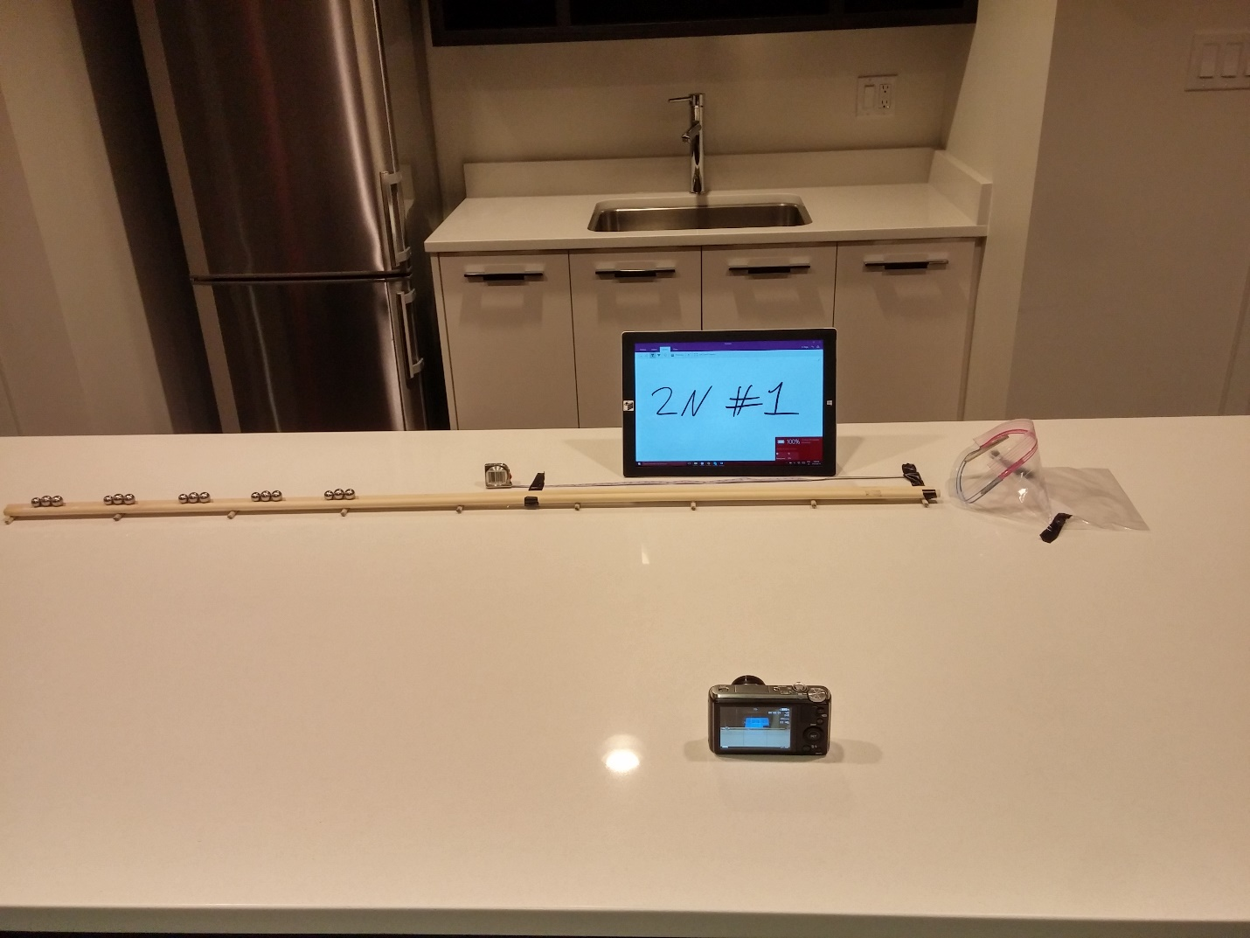

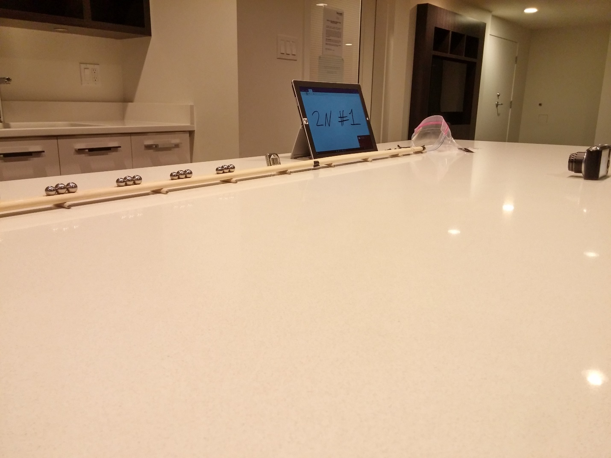

**Appendix 2**

1. I imported each video into Pasco Capstone and entered video analysis mode.
2. Each video was set to the time where the end ball had just entered the 0.500 meter marker and the time elapsed in the video was taken.
3. When each ball had crossed the 0.500 meter marker in the video, I recorded the time elapsed.
4. The time value in step 3 was subtracted by the time value in step 2 in order to obtain the overall time for the ball to cross one half of a meter.
5. Because there were 3 trials for each number of end balls recorded, I averaged the three times into one.

Below are two screenshots of the Pasco Capstone video analysis displaying the high-speed footage of the end ball. When the ball passed the first marker the time was 0.10 seconds and when it passed the second marker the time was 2.93. The difference between the two times was 2.83 seconds which is the time it took for the ball to cross 0.500 meters at 16x slowed video.

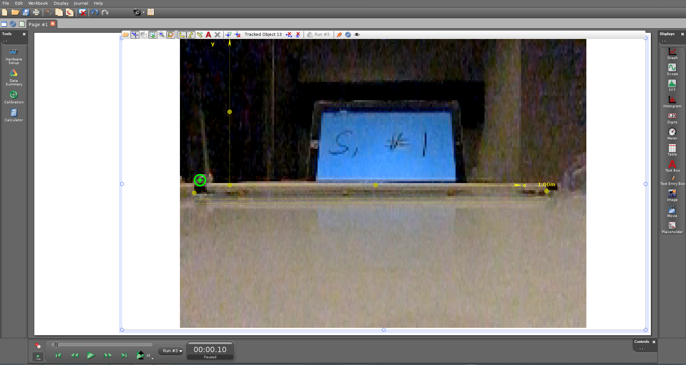

It can be seen here that the ball had just past the first tape marker at 0.10 seconds

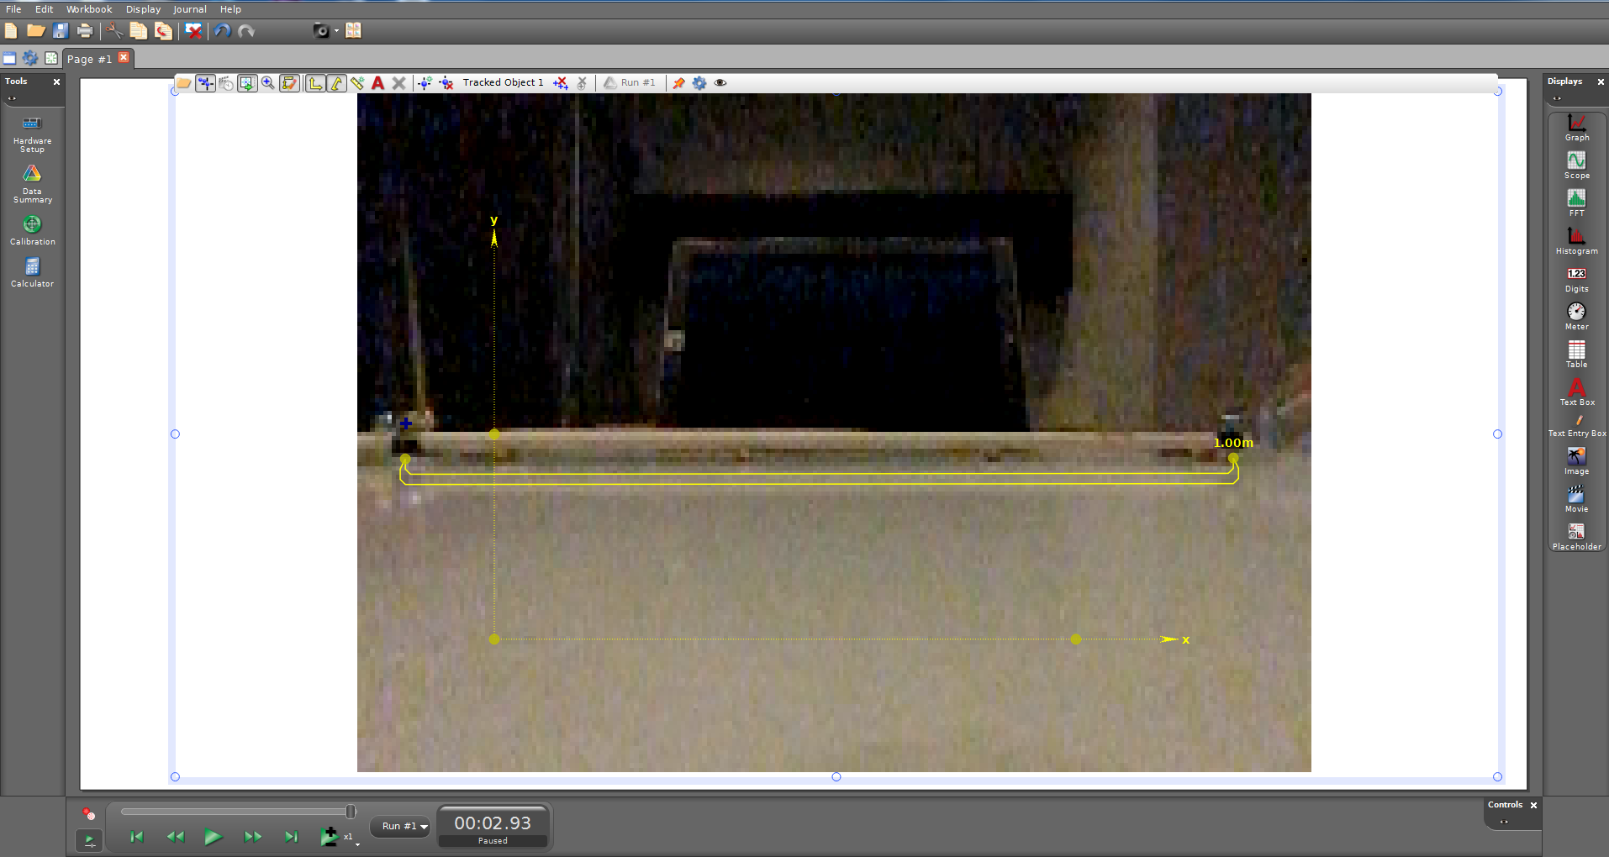

Here the ball had just passed the second tape marker at 2.93 seconds of slowed time.

**Appendix 3**

The times displayed in the three trials were slowed down by a factor of 16 as the videos were shot in 480 frames per second. Therefore to find the velocity they were converted from slowed time to normal time by dividing the value by 16 and then dividing 0.500 meters by the normal time.

|  |  |  |  |  |  |
| --- | --- | --- | --- | --- | --- |
| Number of end balls | Trial 1 data (seconds) | Trial 2 data (seconds) | Trial 3 data (seconds) | Average (seconds) | Velocity (meters/second) |
| 2 | 3.30 | 3.17 | 3.00 | 3.16 | 2.53 |
| 3 | 2.93 | 2.84 | 2.90 | 2.89 | 2.77 |
| 4 | 2.84 | 2.84 | 2.77 | 2.82 | 2.84 |
| 5 | 2.83 | 2.84 | 2.73 | 2.80 | 2.86 |
| 6 | 2.84 | 2.93 | 3.01 | 2.93 | 2.73 |
| 7 | 2.97 | 3.04 | 3.07 | 3.03 | 2.64 |

|  |  |  |  |  |  |
| --- | --- | --- | --- | --- | --- |
| Number of Stations | Trial 1 data (seconds) | Trial 2 data (seconds) | Trial 3 data (seconds) | Average (seconds) | Velocity (meters/second) |
| 1 | 6.54 | 6.24 | 6.21 | 6.33 | 1.26 |
| 2 | 4.04 | 4.04 | 3.93 | 4.00 | 2.00 |
| 3 | 3.27 | 3.23 | 3.33 | 3.28 | 2.44 |
| 4 | 3.07 | 3.03 | 3.00 | 3.03 | 2.64 |
| 5 | 2.87 | 2.77 | 2.77 | 2.80 | 2.85 |

**Appendix 4**

It can be seen here that the track used in this experiment was slightly curved, resulting in a systematic error that likely altered results. When conducting the experiment, projectiles did not seem to be affected by this curve as all magnets and steel balls remained on the track.

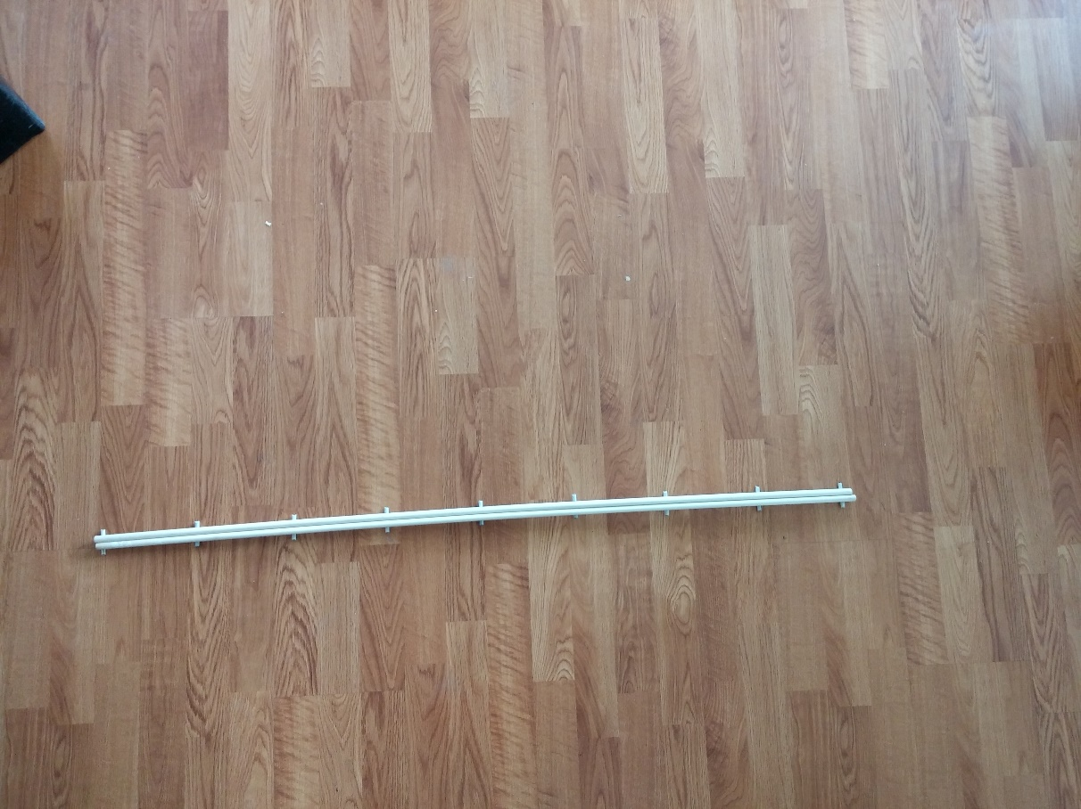

From above, the track looks fairly straight with a very small curve.

